Baroque AI: Publication Prototype

Class participants

4/14/23

Table of contents

# 1. Part of the series: Baroque TOC

[Programme instructions](https://nfdi4culture.github.io/class-ADA-CP-pipeline/)

2023-03-17 v1.0

Example publications:

* Exhibition Catalogue (Work in progress) - https://nfdi4culture.github.io/catalogue-003/ (content from the current repo)
* [Exhibition catalogue demo: toc Baroque /toc](https://nfdi4culture.github.io/experimental-books-workshop/) from Experimental Books – Re-imagining Scholarly Publishing, COPIM. Workshop URL: https://experimentalbooks.pubpub.org/programme-overview
* [Publishers catalogue demo: ScholarLed](https://simonxix.github.io/scholarled_catalogue/) A catalogue of ScholarLed presses built on a Quarto / Jupyter Notebook model for computational publishing. The publication is automatically updated daily to reflect any new books added by the publishers.
* [Proof of concept #1](https://nfdi4culture.github.io/cp4c/) - Computational Publication: Computational Publishing for Collections - ADA CP Prototype #1 - Nov 22
* [Proof of concept #2](https://nfdi4culture.github.io/art_catalogue_test/) - To be confirmed, completion for end of April 2023. This contains all parts fully rendered: Cover, colophon, essay, collection, graph, TIB AV Portal, Semantic Kompakkt
* semanticClimate: To be confirmed - customised research papers readers made for regional climate change action plans based on IPCC reports and sourcing content from open research repositories.
* FSCI Summer School - publishing from collections class: To be confirmed, July 2023

This work is licensed under a Creative Commons Attribution-ShareAlike 4.0 International License.

# 2. Colophon

Fork title:

Author:

ORCID:

Date:

DOI:

Repositor:

PUBLISHING FROM COLLECTIONS USES OF COMPUTATIONAL PUBLISHIGN AND LINKEDOPEN DATA

Open Science Lab - TIB Hannnover

First published 2023-03-30

Copyright © The Authors 2023 Licensed as https://creativecommons.org/licenses/by-sa/4.0/

DOI: https://doi.org/10.5281/zenodo.7701161

# 3. Baroque painting

Source: https://en.wikipedia.org/wiki/Baroque_painting

Baroque painting is the painting associated with the Baroque cultural movement. The movement is often identified with Absolutism, the Counter Reformation and Catholic Revival,[1][2] but the existence of important Baroque art and architecture in non-absolutist and Protestant states throughout Western Europe underscores its widespread popularity.[3]

Baroque painting encompasses a great range of styles, as most important and major painting during the period beginning around 1600 and continuing throughout the 17th century, and into the early 18th century is identified today as Baroque painting. In its most typical manifestations, Baroque art is characterized by great drama, rich, deep colour, and intense light and dark shadows, but the classicism of French Baroque painters like Poussin and Dutch genre painters such as Vermeer are also covered by the term, at least in English.[4] As opposed to Renaissance art, which usually showed the moment before an event took place, Baroque artists chose the most dramatic point, the moment when the action was occurring: Michelangelo, working in the High Renaissance, shows his David composed and still before he battles Goliath; Bernini’s Baroque David is caught in the act of hurling the stone at the giant. Baroque art was meant to evoke emotion and passion instead of the calm rationality that had been prized during the Renaissance.

Among the greatest painters of the Baroque period are Velázquez, Caravaggio,[5] Rembrandt,[6] Rubens,[7] Poussin,[8] and Vermeer.[9] Caravaggio is an heir of the humanist painting of the High Renaissance. His realistic approach to the human figure, painted directly from life and dramatically spotlit against a dark background, shocked his contemporaries and opened a new chapter in the history of painting. Baroque painting often dramatizes scenes using chiaroscuro light effects; this can be seen in works by Rembrandt, Vermeer, Le Nain and La Tour. The Flemish painter Anthony van Dyck developed a graceful but imposing portrait style that was very influential, especially in England.

The prosperity of 17th century Holland led to an enormous production of art by large numbers of painters who were mostly highly specialized and painted only genre scenes, landscapes, still lifes, portraits or history paintings. Technical standards were very high, and Dutch Golden Age painting established a new repertoire of subjects that was very influential until the arrival of Modernism.

## 3.1 History

Nativity by Josefa de Óbidos, 1669, National Museum of Ancient Art, Lisbon The Council of Trent (1545–63), in which the Roman Catholic Church answered many questions of internal reform raised by both Protestants and by those who had remained inside the Catholic Church, addressed the representational arts in a short and somewhat oblique passage in its decrees. This was subsequently interpreted and expounded by a number of clerical authors like Molanus, who demanded that paintings and sculptures in church contexts should depict their subjects clearly and powerfully, and with decorum, without the stylistic airs of Mannerism. This return toward a populist conception of the function of ecclesiastical art is seen by many art historians as driving the innovations of Caravaggio and the Carracci brothers, all of whom were working (and competing for commissions) in Rome around 1600, although unlike the Carracci, Caravaggio persistently was criticised for lack of decorum in his work. However, although religious painting, history painting, allegories, and portraits were still considered the most noble subjects, landscape, still life, and genre scenes were also becoming more common in Catholic countries, and were the main genres in Protestant ones.

The term “Baroque” was initially used with a derogatory meaning, to underline the excesses of its emphasis. Others derive it from the mnemonic term “Baroco” denoting, in logical Scholastica, a supposedly laboured form of syllogism.[10] In particular, the term was used to describe its eccentric redundancy and noisy abundance of details, which sharply contrasted the clear and sober rationality of the Renaissance. It was first rehabilitated by the Swiss-born art historian, Heinrich Wölfflin (1864–1945) in his Renaissance und Barock (1888); Wölfflin identified the Baroque as “movement imported into mass”, an art antithetic to Renaissance art. He did not make the distinctions between Mannerism and Baroque that modern writers do, and he ignored the later phase, the academic Baroque that lasted into the 18th century. Writers in French and English did not begin to treat Baroque as a respectable study until Wölfflin’s influence had made German scholarship pre-eminent.

### 3.1.1 National variations

Led by Italy, Mediterranean countries, slowly followed by most of the Holy Roman Empire in Germany and Central Europe, generally adopted a full-blooded Baroque approach.

A rather different art developed out of northern realist traditions in 17th century Dutch Golden Age painting, which had very little religious art, and little history painting, instead playing a crucial part in developing secular genres such as still life, genre paintings of everyday scenes, and landscape painting. While the Baroque nature of Rembrandt’s art is clear, the label is less used for Vermeer and many other Dutch artists. Most Dutch art lacks the idealization and love of splendour typical of much Baroque work, including the neighbouring Flemish Baroque painting which shared a part in Dutch trends, while also continuing to produce the traditional categories in a more clearly Baroque style.

In France a dignified and graceful classicism gave a distinctive flavour to Baroque painting, where the later 17th century is also regarded as a golden age for painting. Two of the most important artists, Nicolas Poussin and Claude Lorrain, remained based in Rome, where their work, almost all in easel paintings, was much appreciated by Italian as well as French patrons.

# 4. Activity: Paintings catalogue in Jupyter Notebook

Objective: Make a selection of nine paintings for the exhibition catalogue to be selected from Wikidata and rendered multi-format in Quarto.

The below Python code uses SPARQLWrapper to retrieve data from Wikidata based on a SPARQL query.

Wikidata link: <http://www.wikidata.org/entity/Q19930126>

Title: Battle Painting

Year: 1650

Creator: Johann Heinrich Schönfeld

Copyright: public domain

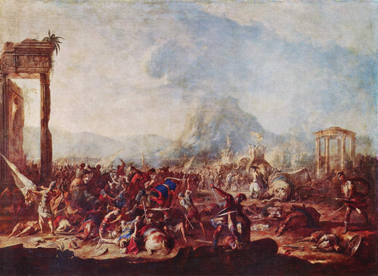

Wikidata link: <http://www.wikidata.org/entity/Q19930364>

Title: Rocky Landscape with Antique Ruins

Year: 1657

Creator: Nicolaes Pieterszoon Berchem

Copyright: public domain

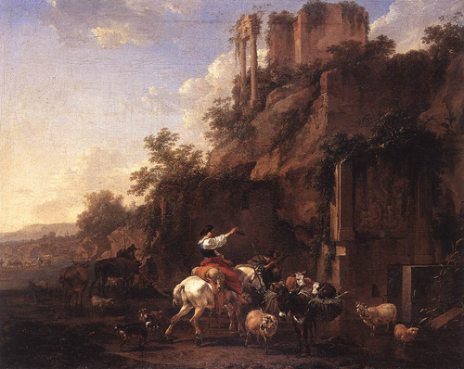

Wikidata link: <http://www.wikidata.org/entity/Q19930472>

Title: Riding School Before Ancient Ruins

Year: 1750

Creator: Pieter van Bloemen

Copyright: public domain

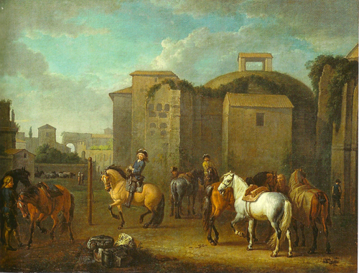

# 5. Custom Collection - SW

Custom Collection by Simon Worthington (April 23): Paintings by Lucas Cranach the Elder https://www.wikidata.org/wiki/Q191748.

The collection Notebook only contains the SPARQL query and needs additional Python adding to parse the metadata output.

Madonna under the Fir Tree 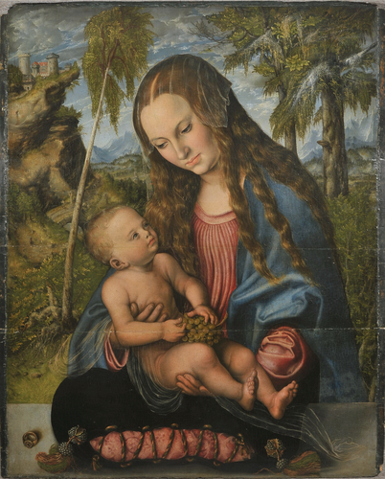

Saint Eustace 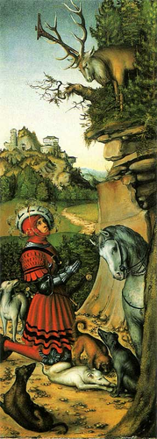

Judith with two female companions 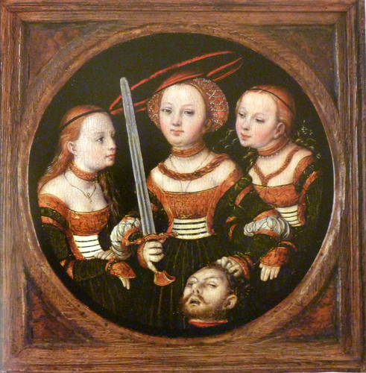

Maria Hilf 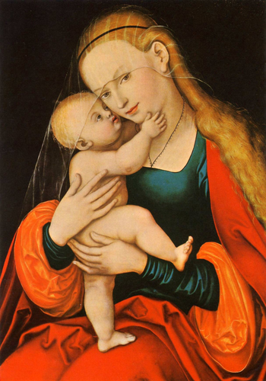

Cupid Complaining to Venus 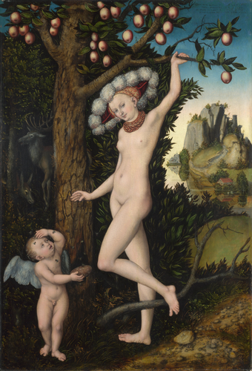

The Three Graces 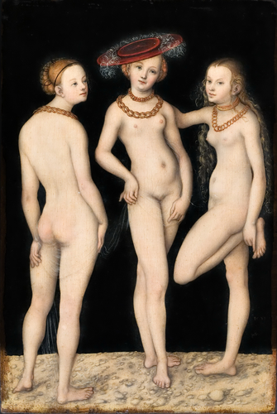

The Crucifixion with the Converted Centurion

c:\Users\simon\AppData\Local\Programs\Python\Python39\lib\site-packages\PIL\Image.py:3074: DecompressionBombWarning: Image size (121328284 pixels) exceeds limit of 89478485 pixels, could be decompression bomb DOS attack.  
 warnings.warn(

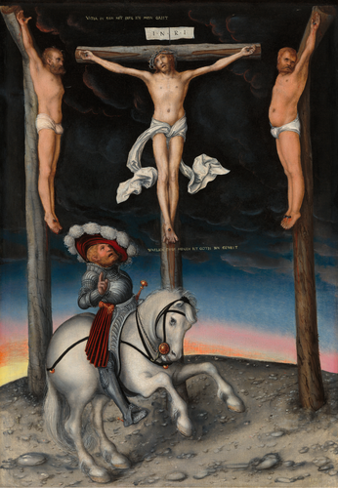

Madonna with Child with Young John the Baptist 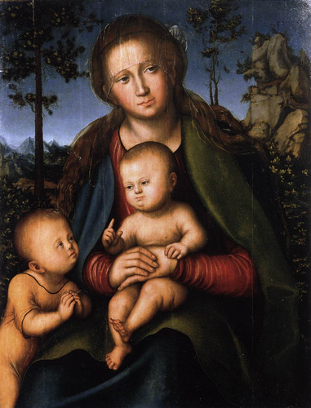

Female Portrait 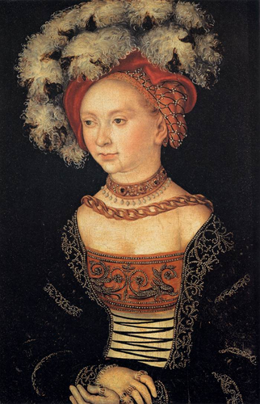

Melancholy 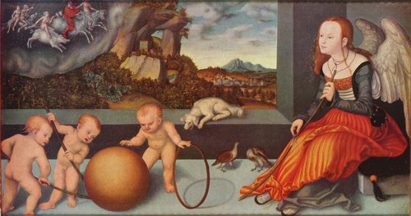

Melancholy 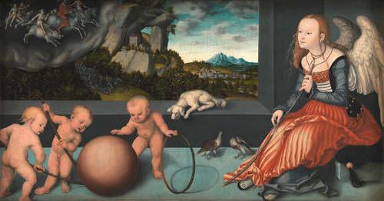

Cardinal Albrecht of Brandenburg in front of the Crucified Christ 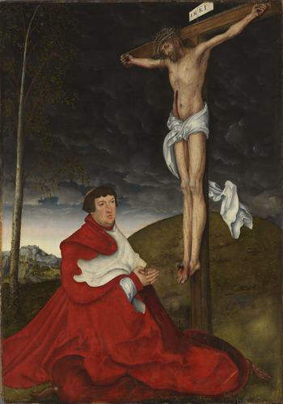

A Faun and His Family with a Slain Lion 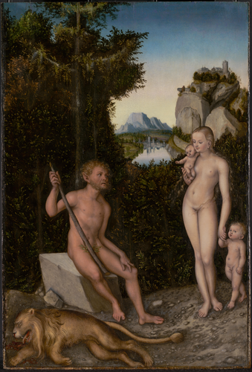

Rest on the Flight to Egypt 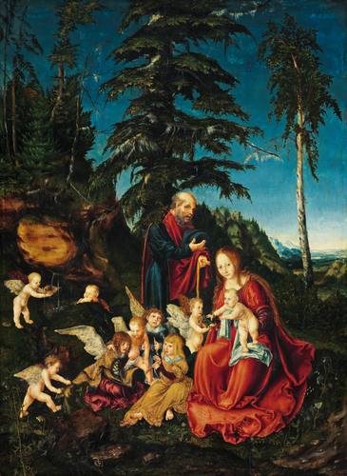

The Crucifixion 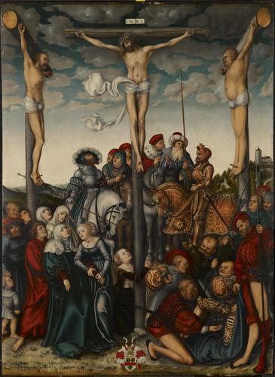

Adam and Eve 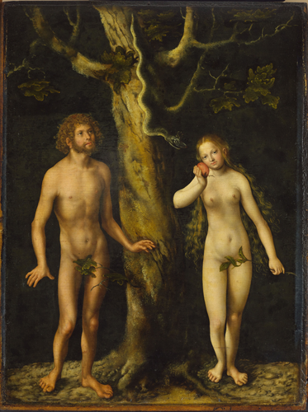

Christ blessing the children. 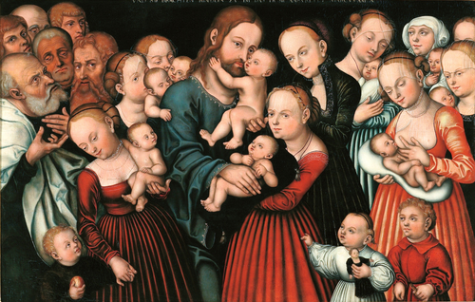

Portrait of a girl with forget-me-nots 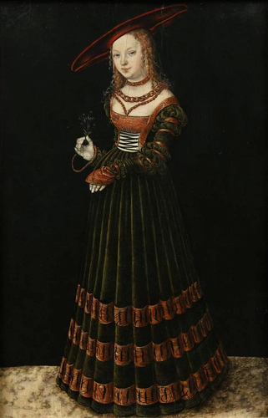

Herkules and Omphale 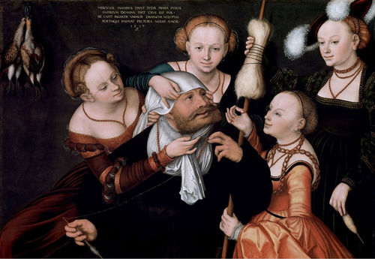

Madonna and Child 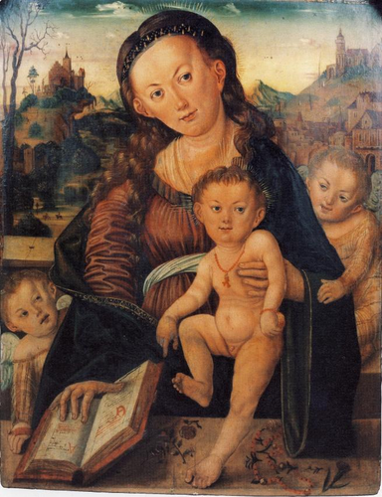

Virgin and Child with Saint Catherine of Alexandria 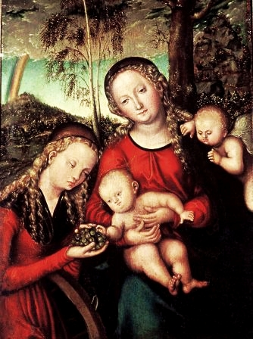

The Mystic Marriage of Saint Catherine of Alexandria with Saints Dorothy, Margaret and Barbara 